MGT-305-003-2021-030>> Assignments>> Module 2 - Online Virtual Classroom Lecture & Discussion

- Find a company in recent news that has launched a new product or service.

Sovmiku recently launched a mini HD wireless camera that is the size of a USB thumb.
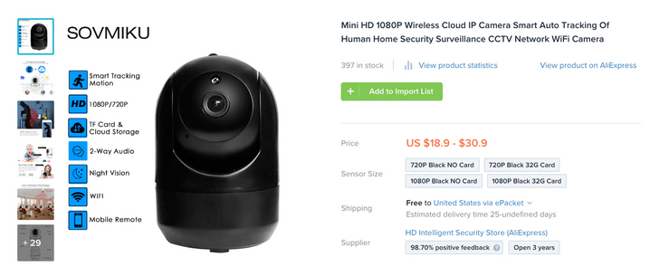
- How has the market reacted to this launch?
The market has had a mixed reaction to this product. While some consider it as ideal to monitor homes and workplaces secretly other raise the ethical concerns on spying on others. For instance, for couples using the product to spy each other, it may likely not end well for them.

- Do you think this offering will be successful long term?
Yes. I strongly believe that it will be success in the long run.

- Why or why not?
The market love portable devices and increasingly security has become of great concern. For example, it would be always tempting for a parent to use the device to see how the nanny is taking care of their baby and so on. Based on its low pricing and convenience in usage, the market will eventually accept this product. Besides the world has become very tech-savvy and despite the controversy over this spy camera (privacy issues), it would be accepted in the long run.

- Consider a high volume fast food versus a high-end sit down restaurant.
- How might they operate differently?
The high volume fast food enterprise molds its processes on meeting large volume of customers who need pretty much similar or well-defined products. The products are not much customized which means that the emphasis is more on volume than variety. On the other hand, high end sit down restaurants prioritizes customized orders as opposed to volume. Therefore, they will operate with lower volumes but ensure that variety is achieved.

- What are the implications to the layout of each restaurant?
The fast food restraint will prefer a product focus layout which supports high volume and low variety in its operations. Alternatively, the sit-down restaurant will adopt the process layout due to low volumes but more complexity/differentiation of its products and services.

.

